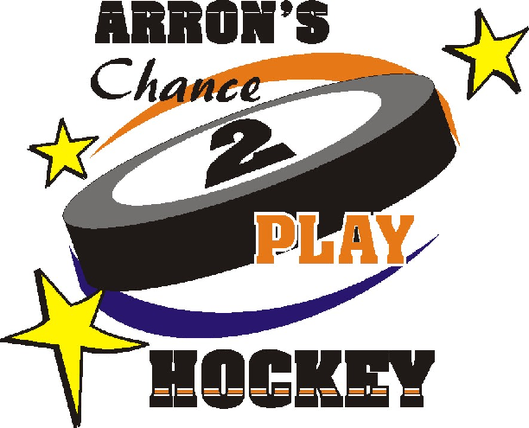
CanSkate Application 2025/2026

Step 1 – Eligibility
Before you begin, determine your eligibility:
Eligibility for the program is based on your Household Size and Total Family Income. Please determine if you are eligible. Please circle your Household Size and Maximum Income level.
Total Family Household Size | Maximum Allowable Total Family Income
2 | $35,498
3 | $42,322
4 | $50,135
5 | $56,111
6 | $62,549
7+ | $68,986

**PLEASE SUBMIT VERIFICATION OF YOUR INCOME (LAST YEAR’S INCOME TAX SUMMARY) WITH THE APPLICATION**

**PLEASE SUBMIT YOUR CONTRIBUTION WITH THE APPLICATION**
Parental Contribution:
1st child: $20.00
Every child after that: $15.00 each
Maximum parental Contribution of $50.00
For example: If you have 2 children playing hockey your family contribution would be $35.
** APPLICATIONS WILL NOT BE PROCESSED WITHOUT VERIFICATION OF INCOME AND THE PARENTAL CONTRIBUTION

Step 2 – Personal Information

Name(s) of Child(ren) in family Household:  1) ___________________________________________ Male Female  2) ___________________________________________ Male Female  3) ___________________________________________ Male Female  4) ___________________________________________ Male Female |  | Birth date(s):  1) ________________________  2) ________________________  3) ________________________  4) ________________________
Custodial Parental Information:
Mother/Guardian: | Father/Guardian:
Last Name: ________________________________  First Name: ________________________________  Address: __________________________________  City: _________________ Postal Code _________  Phone: Home ____________ Work _____________  Email:_____________________________________ | Last Name: ________________________________  First Name: ________________________________  Address: __________________________________  City: _________________ Postal Code__________  Phone: Home ____________ Work _____________  Email: ____________________________________
☐ I have full custody ☐ I share custody  *I have a live-in partner other than the child’s father  ☐ Yes ☐ No | ☐ I have full custody ☐ I share custody  *I have a live-in partner other than the child’s mother  ☐ Yes ☐ No
Alternative Contact Information:
If you want the Coordinater to speak with someone other than yourself regarding your child(ren)’s application, please indicate:

Name: _______ Phone: ____________

Relationship to Child: __________________________ Email: ___________________________________

Step 3 – Financial Information
Total Family Income: Please indicate your total family income for last year from ALL sources. Include employment income, child support, EI Benefits, Income Security etc. Please supply copies of financial documents, the summary sheet from last year’s income tax is preferred.
If custody is shared, please submit income information for BOTH parents.
Income Source | Mother/Guardian | Father/Guardian
Employed? | ☐ Yes ☐ No | ☐ Yes ☐ No
Employer Name
Annual Wages / Salary | $ | $
Income Assistance | $ | $
Employment Insurance | $ | $
Child Maintenance Received | $ | $
Other | $ | $
Total Annual Income  from ALL sources | $ | $
Step 4 – Program Information
The Foundation will cover full hockey registrations. If registration fees are less than $400, additional funds may be available for equipment up to a total maximum of $400 per child.
Funding request for: ☐ Hockey Registration ☐ Partial Equipment**

** Equipment: Please specify what equipment was purchased. Receipts are required for reimbursement.
Things You Need To Know
- An application does not guarantee a sponsorship.
- There is no limit on the number of children sponsored from one family.
- The Chance 2 Play Hockey Fund does not sponsor children in Agency care.
- You are responsible for getting your child to the rink. The hockey association with which your child is registered has the right to inform us if your child is not attending practices and games on a regular basis.
- Our fiscal year runs from April 1 to March 31.

Can we contact you to share your child’s experience in feature articles such as newspapers, radio, and Foundation newsletters? Yes ☐ No ☐

How were you made aware of Arron’s Chance 2 Play Hockey Fund?
☐ Newspaper ☐ Radio ☐ Friend ☐ School ☐ Poster ☐ Agency/Worker
☐ Hockey Club ☐ Other

Declaration:
I have read and understand the attached eligibility criteria and, by my signature below, declare the above information to be true:

Signature: _______________________ Date: _____________ Relationship to player: ________________

CanSkate Application 2025/2026
Verification of Registration

PLEASE TAKE TO YOUR CHILD’S MINOR HOCKEY ASSOCIATION OR COACH

Child’s Name: ___________________________________________________________

Supplementary Information to be completed by Organization Board Member
** PLEASE PRINT **

The organization is the club with which the athlete is registered or will be registering. Only the President, Vice President, Registration Chair, Secretary, or Treasurer of the organization’s Board of Directors are eligible to sign the application form.

Organization: _______________________________________________________________________
Club Name: _______________________________________________________________________
Program Start Date: ____________________________ Completion Date: _______________________
Registration Fees: $ ____________________________ ** Registration Fees only – This amount cannot include ice time, uniform fees, travel, raffle tickets, etc.

Organization’s Board Members Responsibilities:

Your responsibilities when signing this form are:
- Confirm that the athlete is registering for the requested program.
- Confirm the requested fee.
- Attach a copy of the invoice.
- Inform the “CanSkate” Program if a child is not attending practices and games on a regular basis.
Boards Members Name: _________________________________________________________________
Organization’s Address: ___________________________________ Town: ________________________
Postal Code: _______________ Telephone: Business ________________ Residential _______________
Fax: ________________________ Email: ___________________________________________________

Verification of the Applicants Registration: _________________________ _________________________
Signature of Board Member Position

Please note – The Foundation cannot process an application without the following information:
☐ Completed Canskate Application | ☐ Signed Declaration | ☐ Financial documents verifying income | ☐ Verification of Registration | ☐ Family Contribution  *Cheques made out to CFSCM*

Please send completed forms to:
CanSkate c/o Child & Family Services of Central Manitoba
25 3rd Street SE, Portage la Prairie, MB R1N 1N1
Phone: 204-857-8751 Fax: 204-239-1413
Website: www.cfscmfoundation.ca
Additional applications can be downloaded from our website.

